Name: Jeffrey Ma, 2L (on leave from 2023-2025)

Organization: United Nations High Commissioner for Refugees (Human Rights Liaison Unit)

Brief Statement:

My experience interning in the Human Rights Liaison Unit (“HRLU”) of the United Nations High Commissioner for Refugees (“UNHCR”) was monumental with respect to both personal and professional growth. In my role, I was afforded the chance to work on projects which felt truly meaningful, and which painted a much clearer picture of what a career in international law might actually look like. Through my internship, I was given the chance to attend the Human Rights Council, draft a speech for the Assistant High Commissioner for Refugees, and prepare statements which were presented before the Treaty Body Committee for the International Convention against Torture, among various other highlights. Moreover, I am deeply grateful to have had the chance to integrate myself into the vibrant and diverse intern community at UNHCR. Meeting and befriending so many talented and passionate people from around the world has been an irreplaceable experience and has allowed me to forge connections which I hope will remain meaningful far into the future.

Overview:

Human Rights Liaison Unit

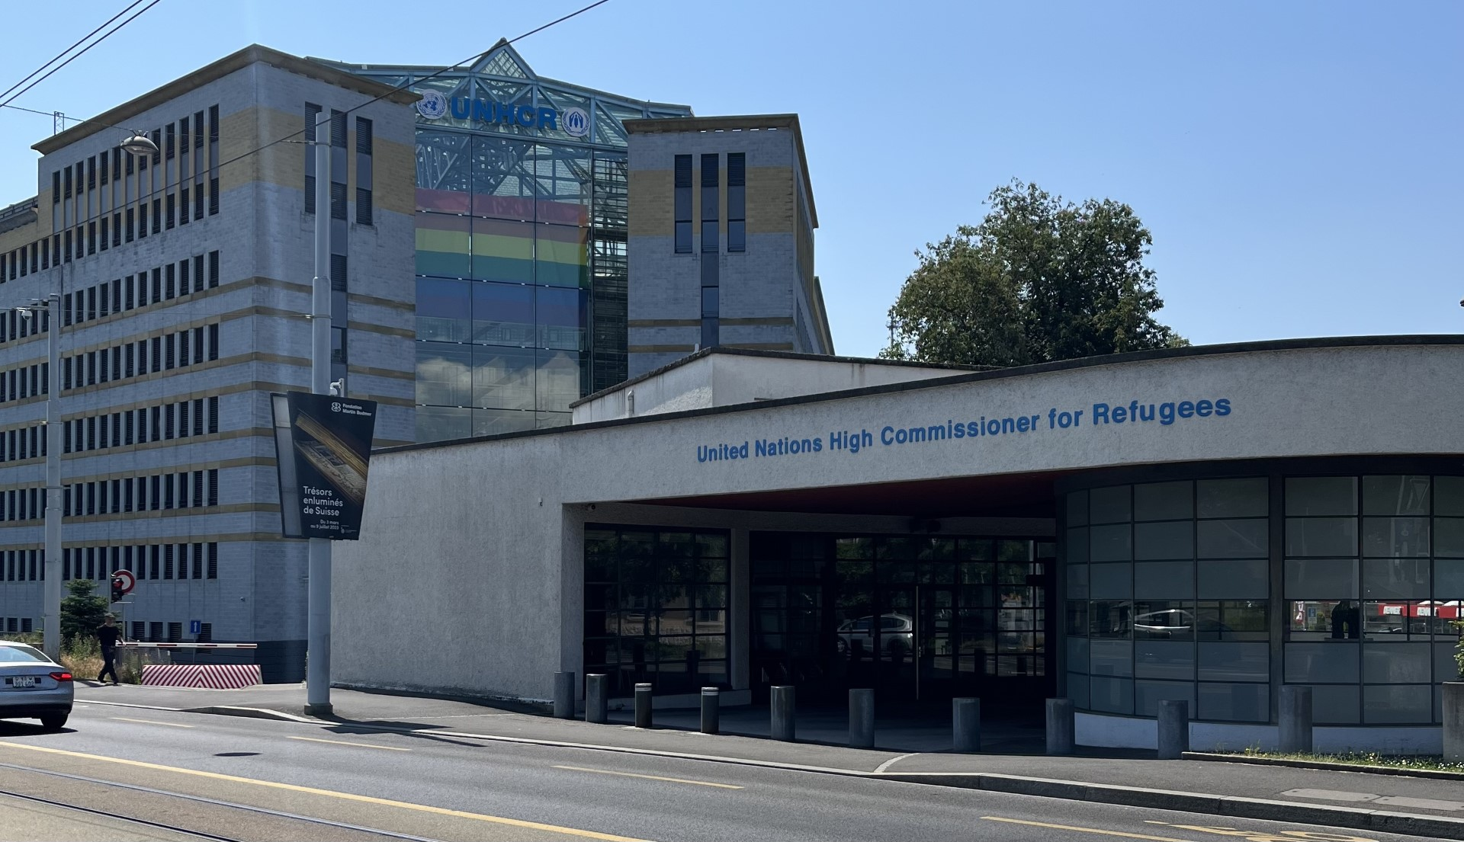
Image 1. UNHCR Headquarters, Rue de Montbrillant 94 in Geneva, Switzerland
Through the IHRP, I was able to intern in the Human Rights Liaison Unit (“HRLU”) of the United Nations High Commissioner for Refugees (“UNHCR”). In the broadest sense, the HRLU’s work lies at the juncture between human rights law (i.e., international human rights treaties, treaty bodies committees, etc.) and UNHCR’s persons of concern. While the HRLU is a relatively small unit, it is within the broader Protection Policy & Legal Advice Section, underneath the Division of International Protection. Accordingly, throughout the summer, I was given the chance to work on topics which concerned both international human rights law and international refugee law. I was very fortunate to have the opportunity to not only approach these topics from the perspective of legal research, but to observe and participate in their practical applications under the supervision of two incredibly kind and knowledgeable supervisors.

Human Rights Engagement Training

One of my first assignments working in the HRLU was to support the unit in a Human Rights Engagement Workshop which was to be held in-person with UNHCR field colleagues in Iraq. The purpose of the workshop was to illustrate avenues through which human rights mechanisms could be utilized to complement our colleagues’ work in the field.
I conducted research on the international, regional, and national human rights frameworks in Iraq in order to better inform the training workshop. This included reviewing the most recent reports of each of the treaty body committees relating to the nine core international human rights treaties and distilling the most relevant recommendations contained therein. I also had the opportunity to research regional frameworks (i.e., the Organisation of Islamic Cooperation’s human rights system) as well as Iraq’s national human rights infrastructure. While I did not get to go to Iraq in-person, this first assignment allowed me to better understand the relationship between various frameworks and the manner in which they inform each other and the on-the-ground realities they are intended to pertain to.

Human Rights Council

The most substantive (and exciting!) assignment I worked on during my time with the HRLU was attending the 53rd regular Human Rights Council session (“HRC 53”). As the United Nations’ primary human rights body, HRC 53 covered a vast array of human rights topics including the Rohingya refugee crisis, the ongoing conflict in Ukraine, the conflict in Sudan, and the human rights implications of emerging digital technologies. In my role, I was tasked with attending and taking notes on sessions most relevant to UNHCR’s persons of concern. Further, I helped to lead UNHCR’s engagement with HRC53 through coordinating with colleagues who were subject-matter focal points. While the prospect of attending the Human Rights Council was certainly intimidating at first, having the opportunity to attend such a significant forum allowed me to cultivate a much deeper understanding of numerous human rights issues and the manner in which such concerns often intersect.
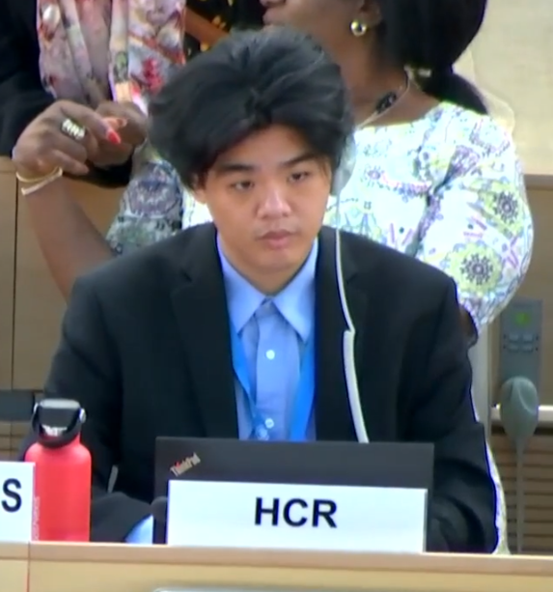
Image 2. Me attending the HRC (from UN WebTV).

Other Conferences

While HRC 53 was the primary conference which I attended during my time with the HRLU, I also had the opportunity to attend several other conferences on relevant topics. This included the RightsCon conference on human rights in the digital age and the Global Summit on Gender and Nationality Laws. While I attended both conferences in Geneva, the sessions of each conference were truly global in orientation and allowed me to gain a much greater perspective on their specific issues of focus.
Another conference which I was able to participate in was the Fourth Annual Nelson Mandela Human Rights Lecture which was a complement to the 15th Nelson Mandela Human Rights Moot Competition. Instead of attending, I had the opportunity to draft the statement of the Assistant High Commissioner, who was slated to provide opening remarks for the event. While I did not get to attend the event in-person, the opportunity to help draft the Assistant High Commissioner’s address was deeply exciting and a highlight of my time with the HRLU.

Treaty Body Committees/Universal Periodic Review

Aside from conferences, my time with the HRLU also allowed me to engage my legal research and writing skills on a regular basis. Most notably, I was tasked with constructing feedback reports which considered to what extent UNHCR’s recommendations and interventions were reflected in the final reports of treaty body committees on a country-by-country basis. This task involved a great deal of close-reading and critical thinking, but, ultimately, through this experience, I gained a much greater sense of how “higher-level” work in international human rights law manifests in tangible outcomes.
In this role, I was even able to flag a mistake which was reflected in a published treaty body report and was able to observe the process of reporting and amending that error. Another highlight was being able to draft an oral statement which was delivered on behalf of UNHCR before the treaty body committee of the International Convention against Torture. I had the chance to attend the treaty body session in the Wilson Palais and observe how my draft helped to produce the final statement which was presented before the committee.

Treaty Guidance Notes

Another task which saw me engaging my legal research and writing skills was the work I completed on the HRLU’s Treaty Guidance Notes. Broadly, the guidance notes are intended to provide an overview for UNHCR colleagues on how they may consider applying each of the nine core international human rights treaties to their work. My task was to complete the drafting and editing of the guidance note for the International Covenant on Civil and Political Rights (“ICCPR”). This task involved considering each of the ICCPR’s articles and providing a brief summary as to how each article relates to the mandate of UNHCR (i.e., relevant case law, definitions, etc.). While this was certainly an ambitious task, completing it allowed me to engage my more “traditional” legal skills through reading legal cases and analyzing the information therein. Moreover, because the audience for the guidance notes include non-legal colleagues, this task challenged me to communicate my research in an accessible manner.

Intern Board

Finally, while interning at UNHCR, I had the opportunity to work with the Intern Board. Composed of around a dozen interns, the Intern Board serves to improve the livelihoods and well being of interns in UNHCR. This includes the organization of recreational social activities as well as more serious matters such as fair pay and treatment. Despite being a relatively young organization, the Intern Board (along with the Fair Internship Initiative) was responsible for successfully advocating for the adoption of an administrative instruction which allowed non-sponsored interns at UNHCR to be financially compensated for their work through a travel/living stipend. Much of the Intern Board’s work remains in its early stages, but, during my time, I saw many exciting ideas take-off including the drafting of constitution, the establishment of a global UNHCR intern directory, a meeting with the High Commissioner himself, and the composition of a survey and research report on timely pay and working conditions, which I had the opportunity to personally contribute to.
Above all else, participating in the Intern Board provided me with an opportunity to connect and befriend an amazing group of young professionals who I hope will remain close friends long into the future. To any future IHRP fellow who may seek to pursue this opportunity, I strongly encourage you to do the same!
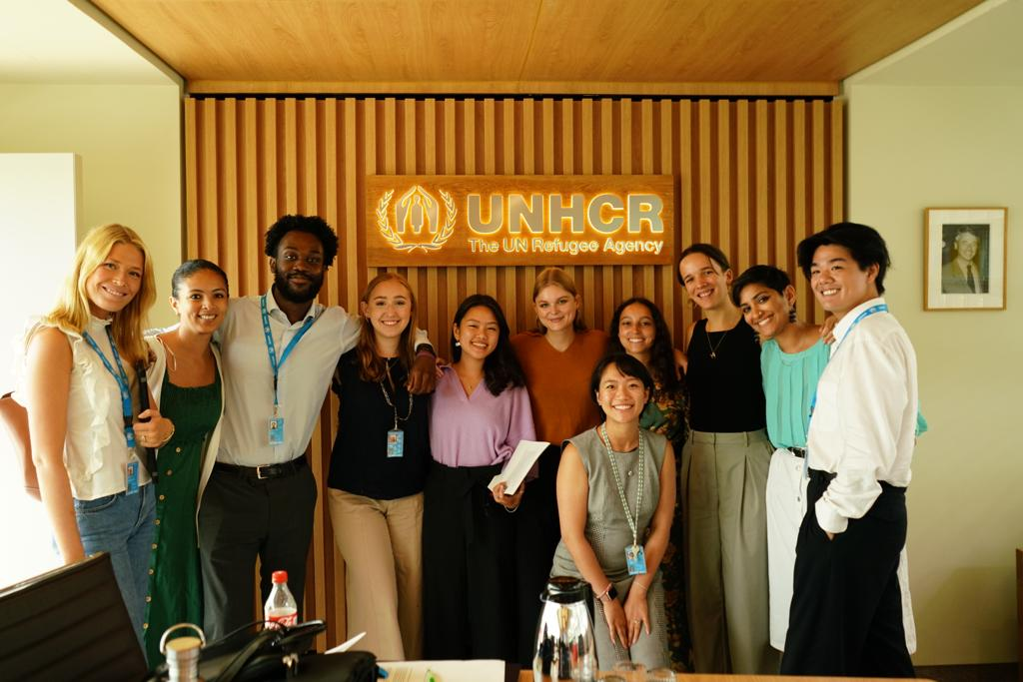
Image 3. Me (far right) and my fellow UNHCR interns at our chat with the High Commissioner
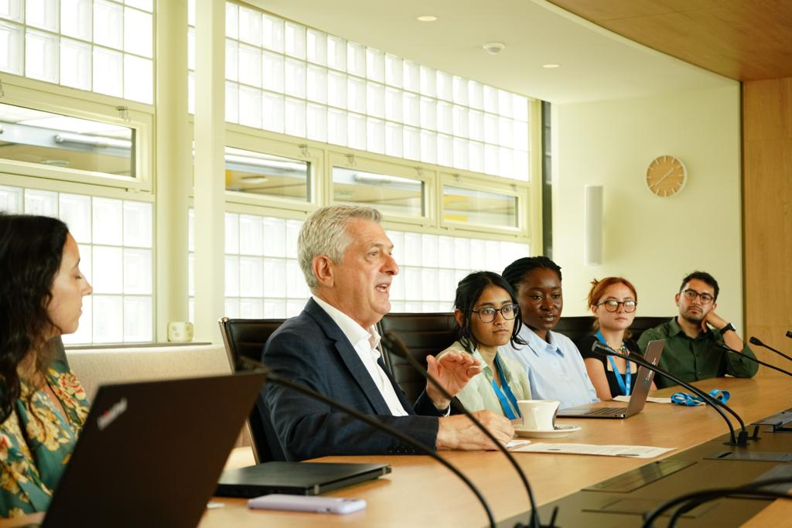
Image 4. The High Commissioner during out intern chat

